**Problem:**

**There are 3 main focus areas of study in a University's course. Maths, CoreComputer subjects and Others. For example: Maths subject is taught in semester1,2,3,4 . Core computer science subjects are taught in sem2,5,6,7. And other area subjects are taught in semester 1 and 2. Make a AI system which can answer the query " Which area subjects are taught in a given semster " . Submit a "Single" file containing following contents :- 1) prolog code- well commented (2) Output screenshot (3) Your understanding of the program/Comment on how this same system can be designed using "c or c++ or java" languages.**

**Solution:**

1. **Prolog code- well commented**

/*Domains Section*/

domains

Sem,Sub=symbol

/*Predicates Section*/

predicates

Show(Sem,Sub)

/*Clauses Section*/

/*sem and the respective subjects...*/

clauses

Show("1","Maths").

Show("1","Other Area Subjects").

Show("2","Maths").

Show("2","Core CS").

Show("2","Other Area Subjects").

Show("3","Maths").

Show("4","Maths").

Show("5","Core CS").

Show("6","Core CS").

Show("7","Core CS").

1. **Output screenshot**

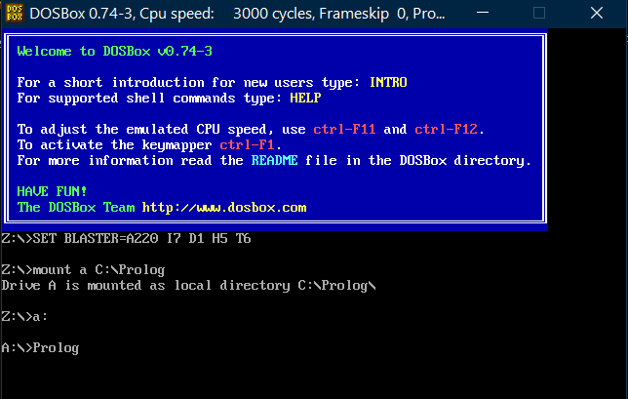

**Alt+F ->File: LAB1.PRO**

**Alt+R -> Goal: Show(“1”,X)+Enter …**

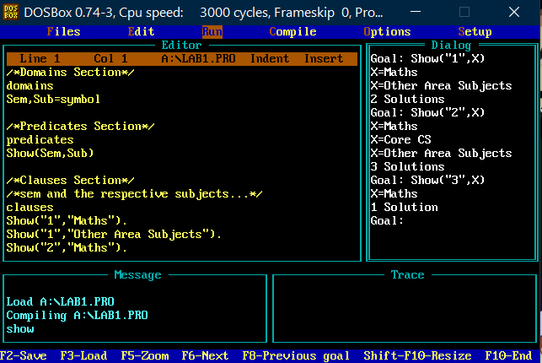

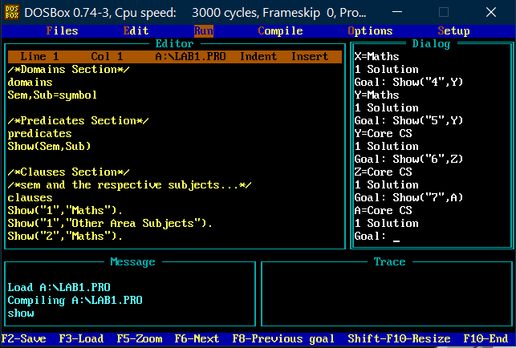

1. **Your understanding of the program/Comment on how this same system can be designed using "c or c++ or java" languages.**

First we will take the i/p from the user the user

Then we will use if else conditions( or we can use switch case also) to give the needed o/p

Logic:

C++ Code

cout<<”Enter Semester:”;

int i;

cin>>i;

if(i==1)

{cout<<”Subjects: Maths, Other Area Subjects”;}

else if(i==2)

{cout<<”Subjects: Maths, Core CS, Other Area Subjects”;}

else if(i==3 || i==4)

{cout<<”Subjects: Maths”;}

if(i==5 || i==6 || i==7)

{cout<<”Subjects: Core CS”;}